NSAA BASKETBALL
OFFICIALS’ CLINIC

The NSAA will be conducting a 3-Person Basketball Officials’ Clinic on November 18, 2006. The purpose of the camps is to train officials in 3-person mechanics. The NSAA will begin 3-person officiating for all post- season contests beginning in 2007. The clinic will consist of classroom instruction followed by actual contest observation and evaluation. Note: Priority for post-season contests in 2007 will be given to officials that have attended an NSAA sanctioned clinic.

3-Person Mechanics Clinic University of Nebraska at Omaha November 18, 2006

Classroom: 8:00 pm –2:00 pm Saturday Officials will be evaluated and feedback provided.

Registration Fee; $ 25.00 Non-Refundable
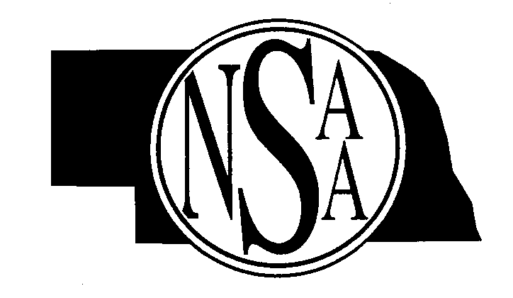
Evaluators:
Mike Peters – Midwest Officials varsity assignor
Dennis Podjenski - Midwest Officials President
Barry Leif – Midwest Officials Mentoring coordinator
Jeff Wallace – Midwest Officials Camp Coordinator
Other State tournament officials

_______________________________________________________________________________________________________

Complete the registration forms with all the necessary information and enclose payment of $25.00.

Return by November 10, 2006

Name____________________________________Address___________________________________________________

City____________________________State______Zip_____________________Telephone # ________________________

E-mail _____________________________

Circle your response:

Count on me to officiate games at the clinic on: Saturday, November 18, 2006

MAIL TO: NSAA
P.O. Box 5447
Lincoln, NE 68505-0447

